Custom Exceptions
For this part we want to throw an exception for the API that return error that related with id such as delete, update and getbyId. So, all of these will throw a new exception if the id are not found.
- In Domain Module, create a file called Exceptions/NotFoundException.cs
  - Make it public class
  - Inherit from Exception base class
  - Create a constructor that return string message, can simplify it by defining the constructor in the class declaration itself
  - The body can remain empty because it inherits all functionality from Exception (like storing the message, stack trace, and being catchable)
- Open DeleteRestaurantCommandHandler.cs
  - Change return false to throw new NotFoundException
  - Remove the bool part
  - Remove return true part
  - Adjust this also DeleteRestaurantCommand to remove bool part
- Similarly, change these files:
  - UpdateRestaurantCommandHandler.cs
    - Remove the Boolean part
    - Adjust this also UpdateRestaurantCommand to remove bool part
  - GetRestaurantByIdQueryHandler.cs
    - Now can adjust RestaurantDto? to RestaurantDto only
    - Adjust this also GetRestaurantByIdQuery to remove symbol “?”
- Open ErrorHandlingMiddleware.cs file
  - Add catch block to catch NotFoundException
- Edit RestaurantsController.cs
  - Remove the var isUpdated and var isDeleted as if got error we can just return NotFoundException
  - Part GetById method, we remove the if statement that check the restaurant is a null or not
- Run the application
- Optional but Recommended Step: Make our NotFoundException become generic by adding 2 parameters which are resourceType and resourceIdentifier.

- Then we update our three files earlier, just edit 1 line only
- UpdateRestaurantCommandHandler.cs
- DeleteRestaurantCommandHandler.cs
- GetRestaurantByIdQueryHandler.cs

Notes:
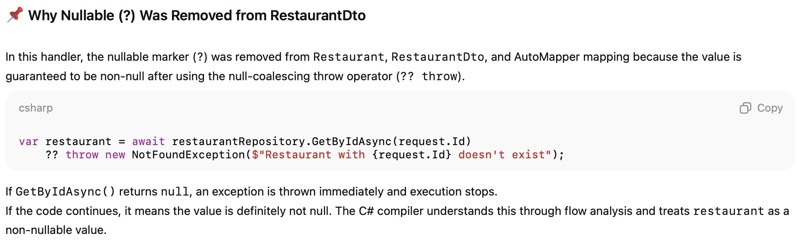
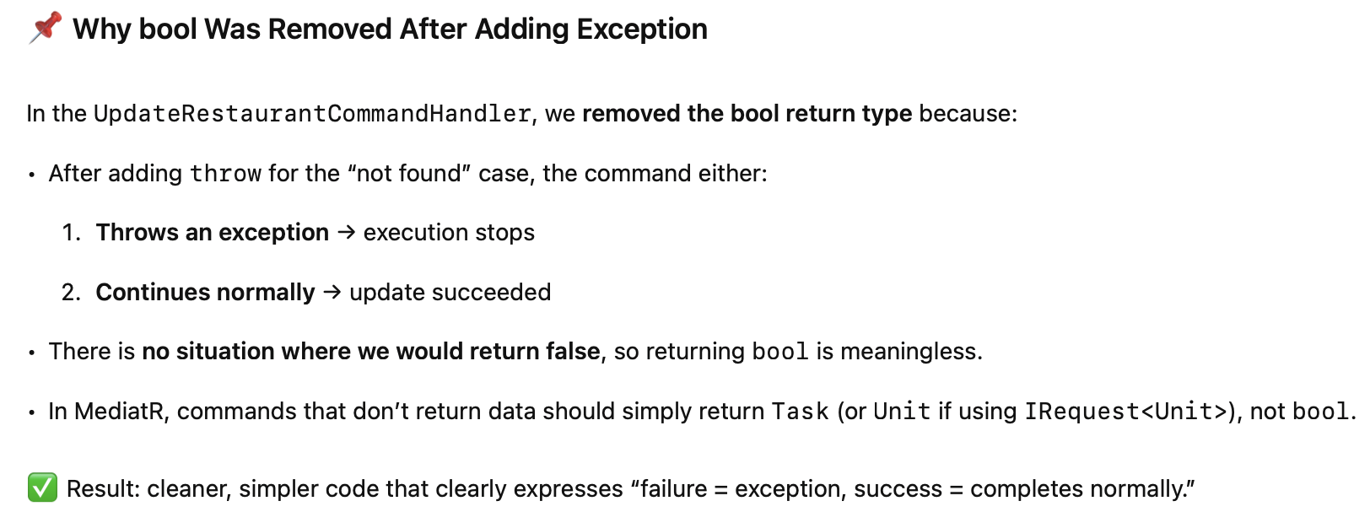
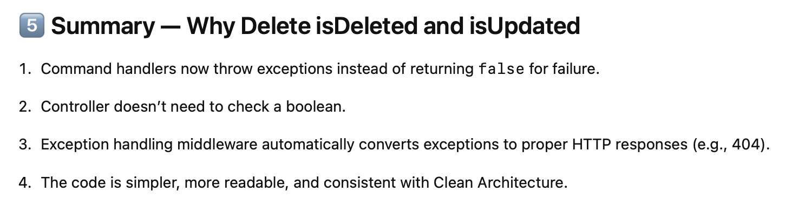

Step by Step Tutorial
- In Domain Module, create a file called Exceptions/NotFoundException.cs
  - Make it public class
  - Inherit from Exception base class
  - Create a constructor that return string message, can simplify it by defining the constructor in the class declaration itself
  - The body can remain empty because it inherits all functionality from Exception (like storing the message, stack trace, and being catchable)
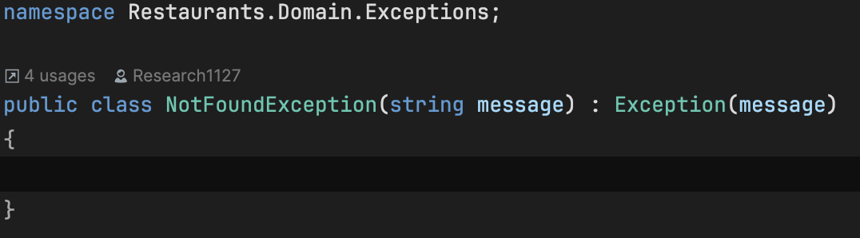
- Open DeleteRestaurantCommandHandler.cs
  - Change return false to throw new NotFoundException
  - Remove the bool part
  - Remove return true part
  - Adjust this also DeleteRestaurantCommand to remove bool part
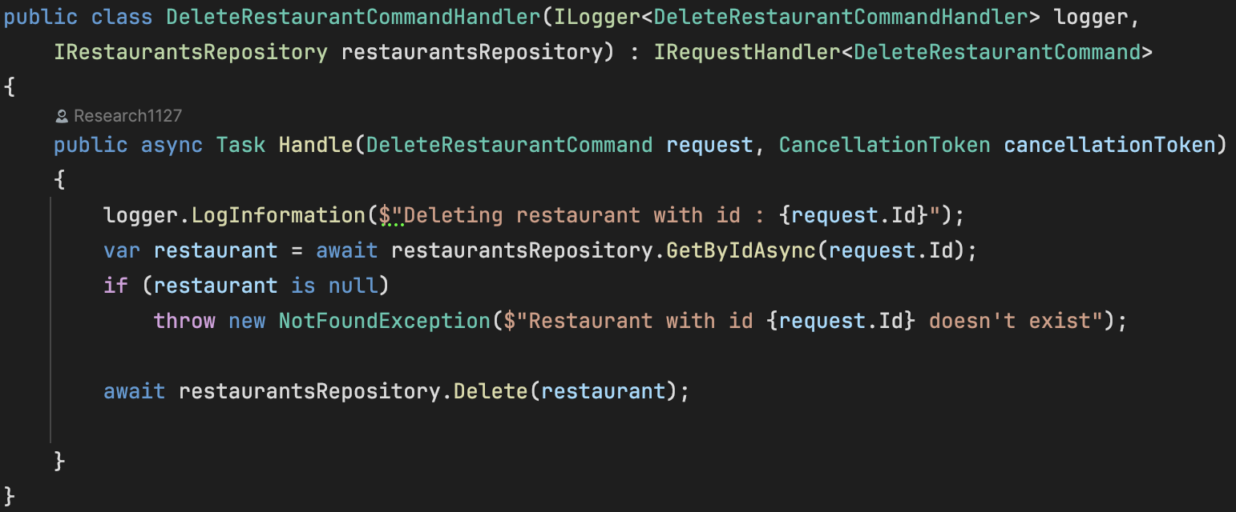

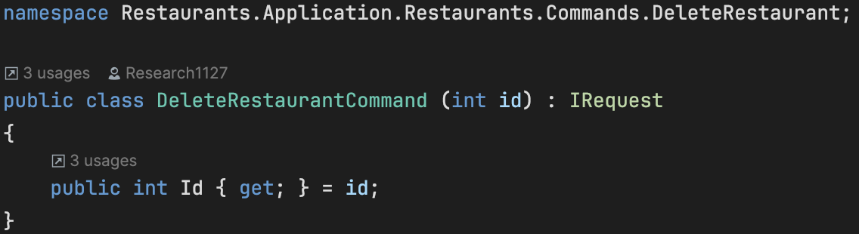
- Similarly, change these files:
  - UpdateRestaurantCommandHandler.cs
    - Remove the Boolean part
    - Adjust this also UpdateRestaurantCommand to remove bool part
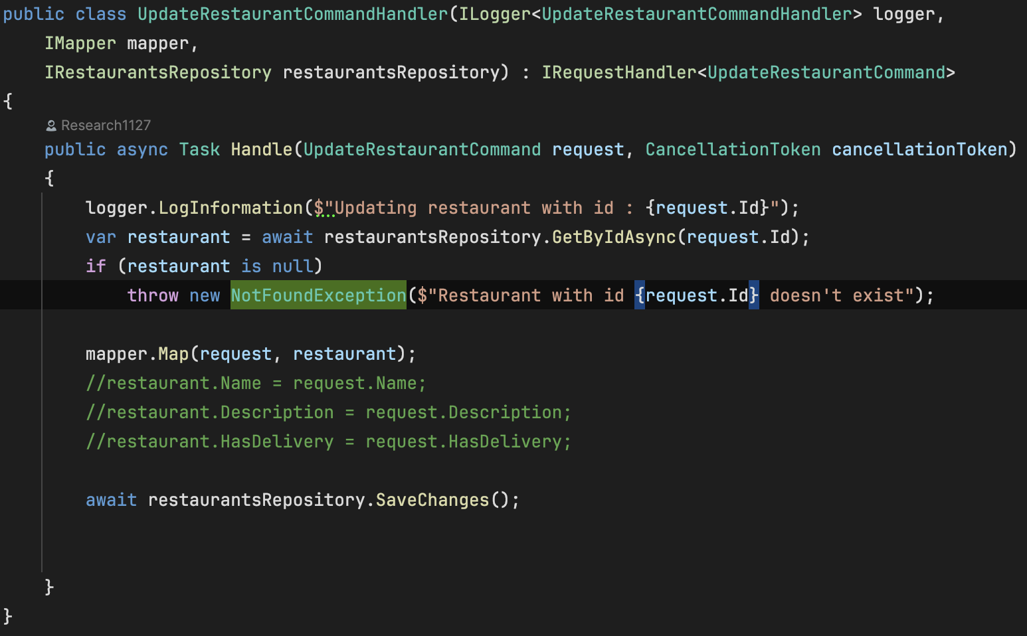
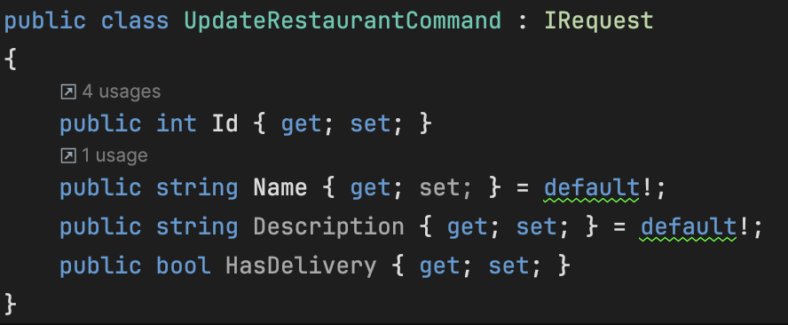
  - GetRestaurantByIdQueryHandler.cs
    - Now can adjust RestaurantDto? to RestaurantDto only
    - Adjust this also GetRestaurantByIdQuery to remove symbol “?”
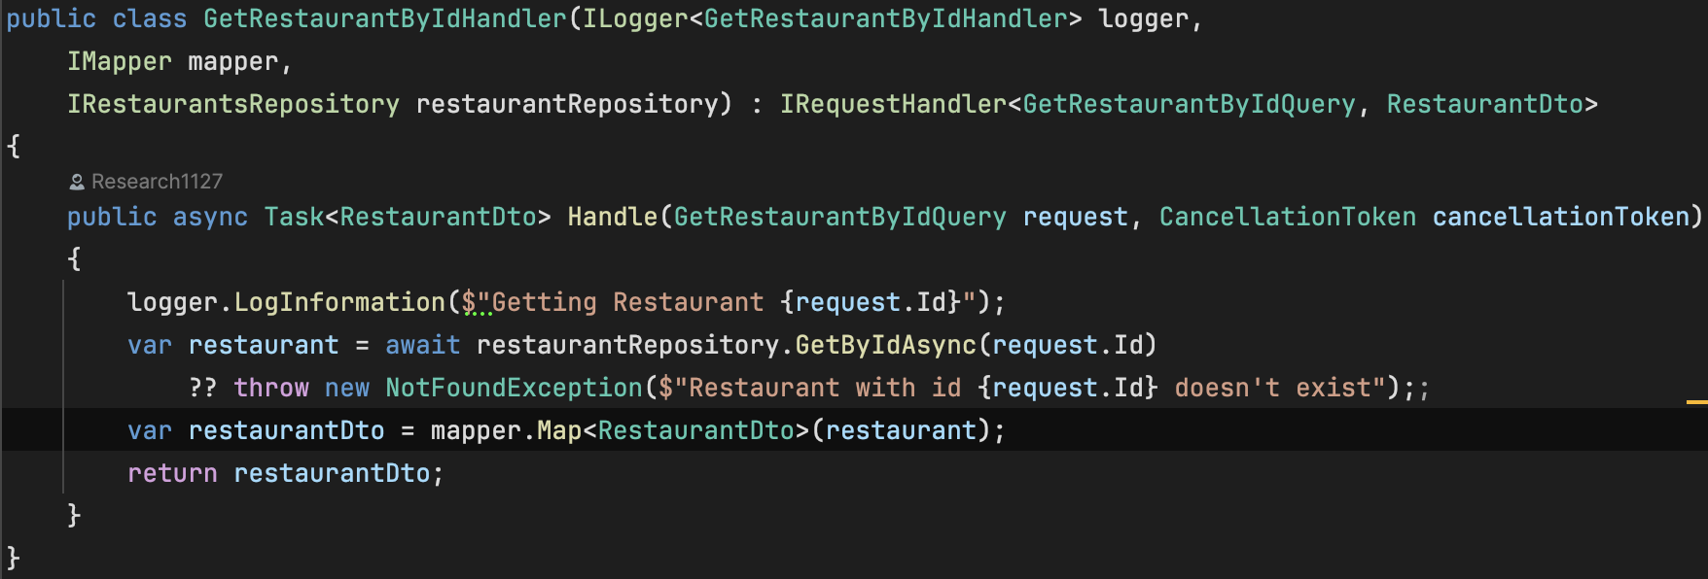
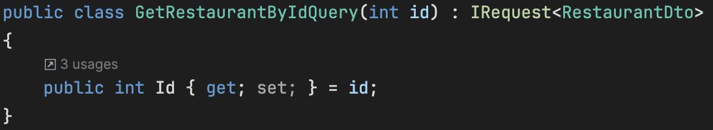
- Open ErrorHandlingMiddleware.cs file
  - Add catch block to catch NotFoundException
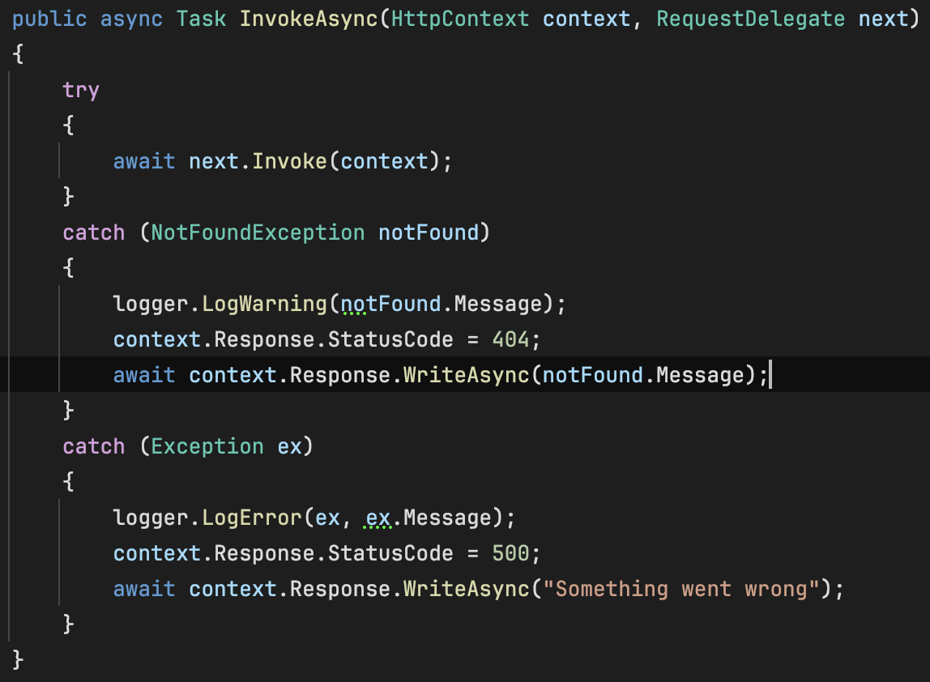
- Edit RestaurantsController.cs
  - Remove the var isUpdated and var isDeleted as if got error we can just return NotFoundException
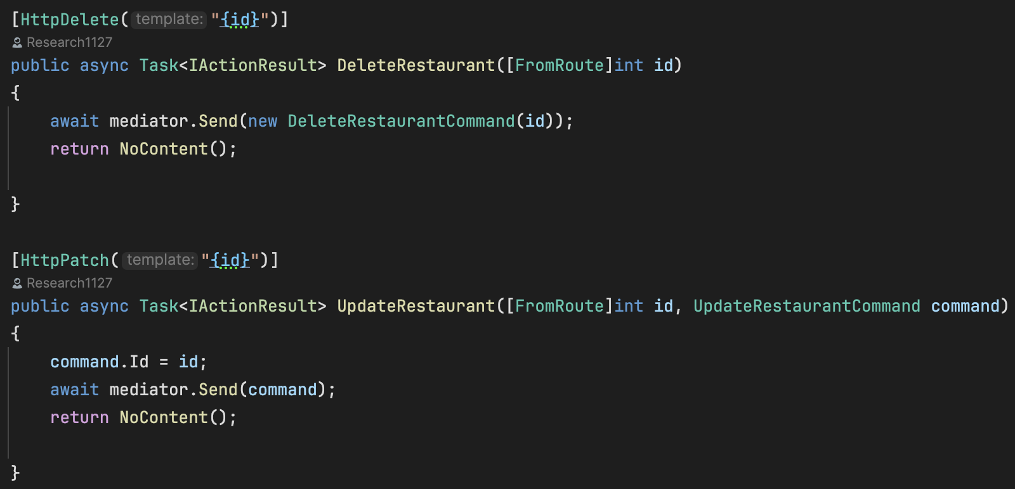
  - Part GetById method, we remove the if statement that check the restaurant is a null or not
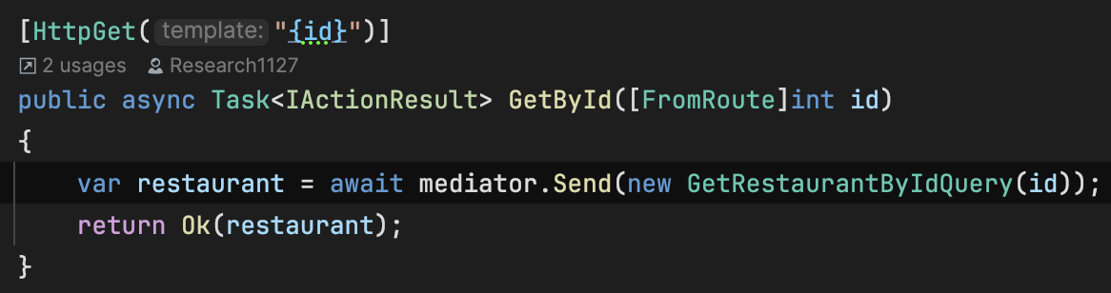
- Run the application to test.
- Optional but Recommended Step: Make our NotFoundException become generic by adding 2 parameters which are resourceType and resourceIdentifier.
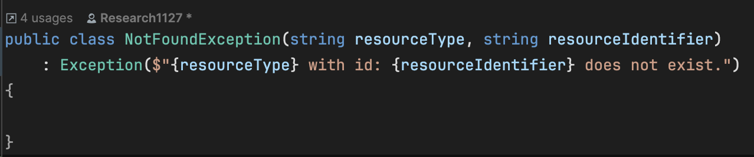

- Then we update our three files earlier, just edit 1 line only
- UpdateRestaurantCommandHandler.cs
- DeleteRestaurantCommandHandler.cs
- GetRestaurantByIdQueryHandler.cs

